**INVITATION FOR AUDIT FIRMS TO PARTICIPATE IN A DONOR SPECIFIC AUDIT SERVICE FOR ONE YEAR ON THE BASES OF FRAMEWORK AGREEMENT**

***Tender Reference # - ITT/IN-SCI-ET-2023-017-R***

SAVE THE CHILDREN INTERNATIONAL (SCI, Ethiopia) the world’s leading independent non-profit organization for children intends to enter agreement for Audit Firms to undertake Donor Specific Audit Service for One Year on the Bases of Framework Agreement.

The Ethiopia Country Office transitioned to Save the Children International (SCI) management in late 2012. This brought seven Save the Children Members under one management structure resulting in better synergies and operational effectiveness. In addition to the 2012 merger, SCI also took over the operations of INGO Merlin in mid-2014. As a result, the organisation became one of the largest INGOs in the country, which further increased our capacity to support programs in hard-to-reach areas for the most vulnerable children and refugees in Ethiopia. Currently SCI operates in all regions of the country in more than 50 offices / locations, over a wide range of thematic programs: Child Protection; Education; Livelihoods, Resilience, and WASH; Health and Nutrition. SCI Ethiopia Programs are financed from different donors and the General Fund allocated from the SCI Centre.

SCI Ethiopian Country Office works with Interim and Final Audit requirements and would like to invite Audit firms to compete for a Framework Agreement that may serve for two consecutive years.

382,260.64

The objective of the audit is to provide an independent professional opinion on the award financial statements, which includes an opinion on the eligibility of expenditure and compliance with the relevant legal agreements with the respective donors.

Thus, interested companies are invited to submit their proposal to provide service for a period of one year, with the possibility of extension upon satisfactory performance and agreement of both parties (SCI and the service provider). The detail criteria is included in the bid document.

Potential audit firms may obtain the tender documents from **December 18, 2023, up to December 25, 2023, during working hours.**

* **Eligibility Documents** – Renewed Valid Business License
* **Company profile** listing the bidders’ address, experience, structure, resources,…etc.
* Proposals must be submitted in Electronic Email Via [**ethiopia.bidsubm@savethechildren.org**](mailto:ethiopia.bidsubm@savethechildren.org), **“bidders’ name**, **address, and the tender reference number and title of the tender should be indicated in the email.** The tender must be submitted in Via Email for the purpose at SCI till **December 25, 2023 @10:00 AM in the morning.**

Save the Children Procurement Committee will open tender responses on **December 25, 2023@10:30 AM in the morning.**

**THE OFFICIAL LINK OF THE BID CAN BE FOUND USING** <https://bit.ly/3Qqe9a7>

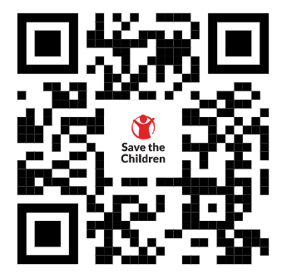

**SCI reserves the right to accept or reject this bid, in partial, or in its entirety.**

**Save the Children International**

**Addis Ababa, Ethiopia**